Monitoring

Contents

1. Introduction 3
2. Workflow diagram to deploy the stack 3
3. Create stack for the Monitoring 4
4. Plan the Job 7
5. Apply the Job 8
6. Verify in the Console 9
7. Destroy the stack 10

Introduction

Monitoring resource provides the Alarm in Oracle Cloud Infrastructure Monitoring service.This call is subject to a Monitoring limit that applies to the total number of requests across all alarm operations.The Monitoring service uses metrics to monitor resources and alarms to notify when these metrics meet alarm-specified triggers. Metrics are emitted to the Monitoring service as raw data points,or timestamp-value pairs, along with dimensions and metadata.

Workflow diagram to deploy the stack

Below diagram shows how the Terraform Artifact are applied in the OCI. While creating a ORM stack, using terraform deliverables Init, Plan and Apply is the flow to provision the resource in the OCI. We can have the deliverables in any of below.

- GitLab/GitHub Repo
- Bitbucket
- Can be in folder/.zip in the local disk
- Object Storage Bucket
- Can be in compartment
- Oracle provided Template

Pre-Request
- Create a Topic and events before code deployed
- Create a Bucket Before code deployed

Create stack for the Events

Go to OCI Console Developer Services Resource Manager Stacks select the compartment Create Stack

My Configuration Folder Browse Select the “Monitoing” folder that contains the terraform Upload

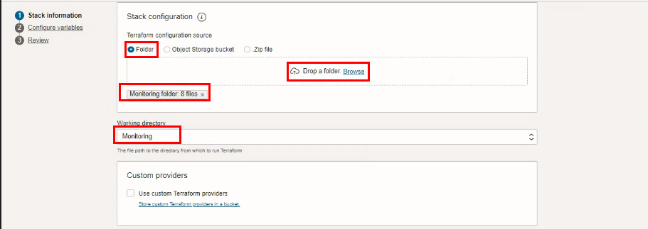

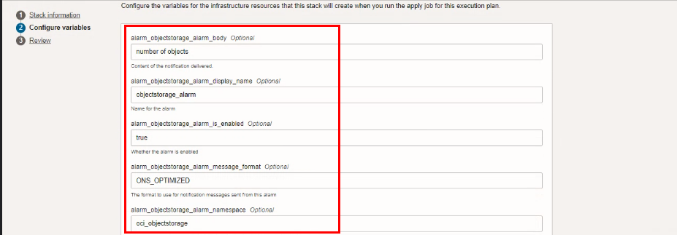

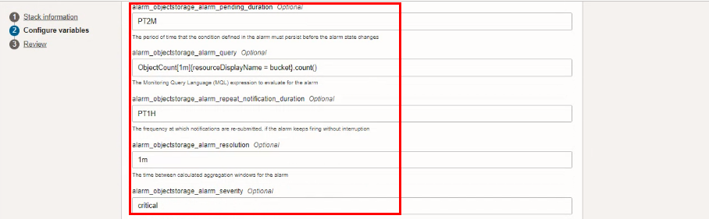

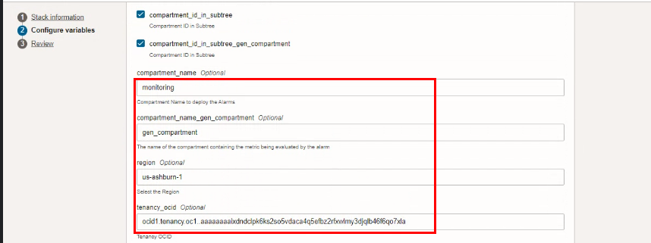

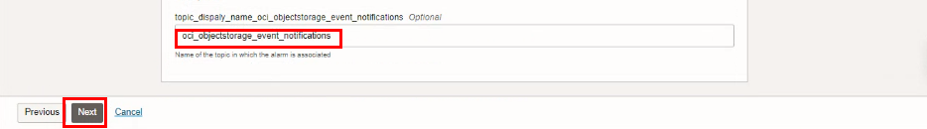

Click “NEXT”
Select the parameters as per the below screen,

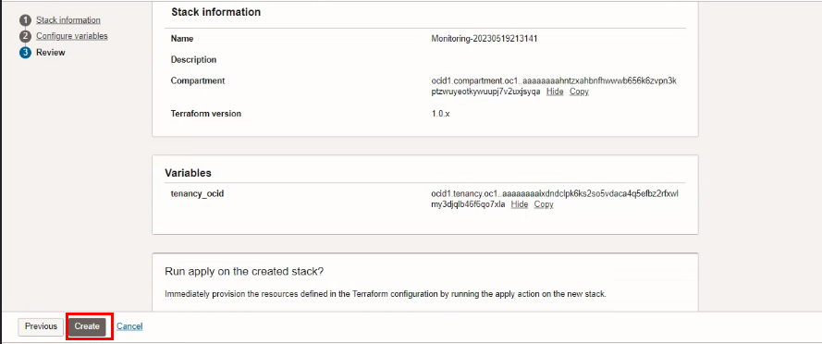

Click “NEXT” Click “CREATE”

Plan the Job
Click the “Plan”

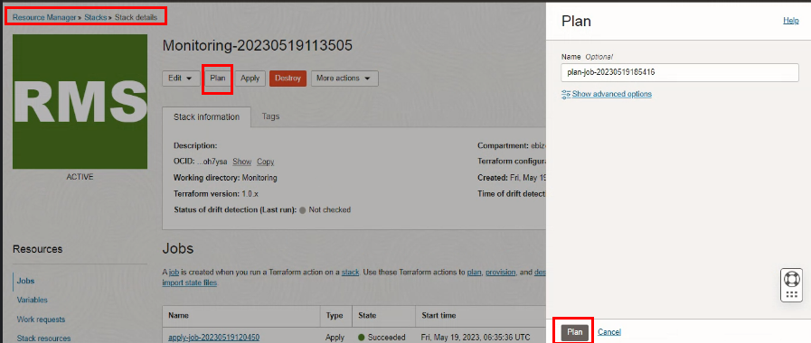

Verify the Plan is successful

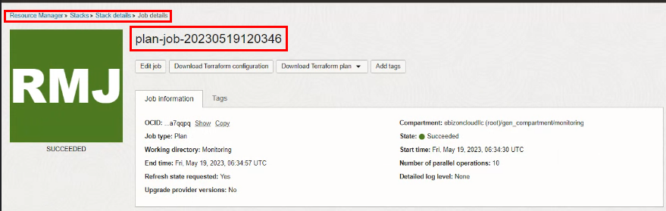

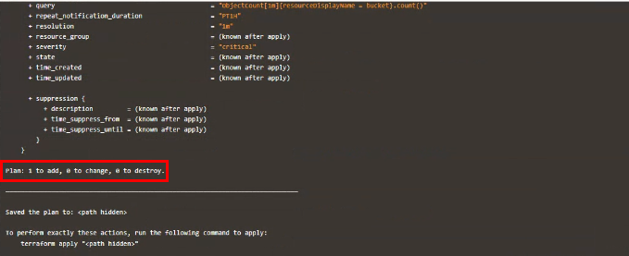

Apply the Job
Once the “plan” is success, now click “Apply”

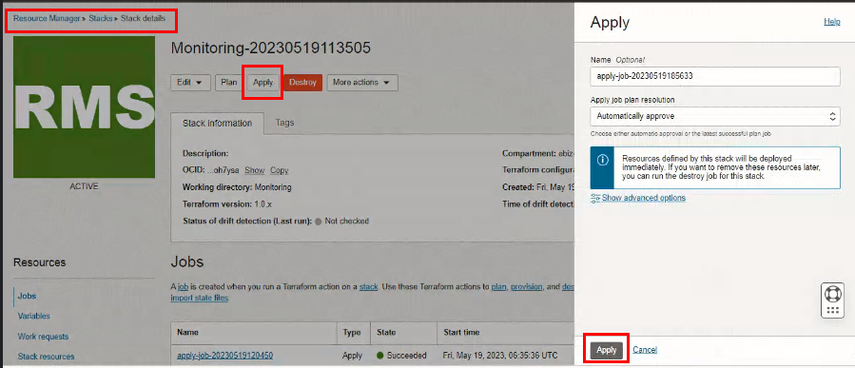

Verify the Apply is successful.
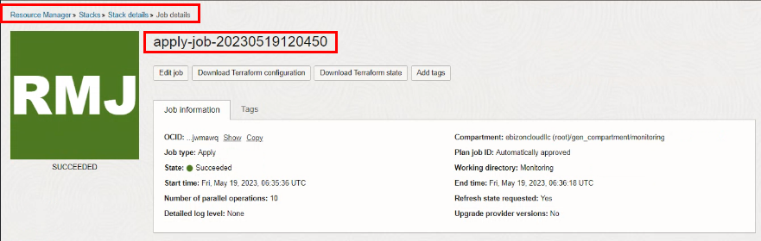

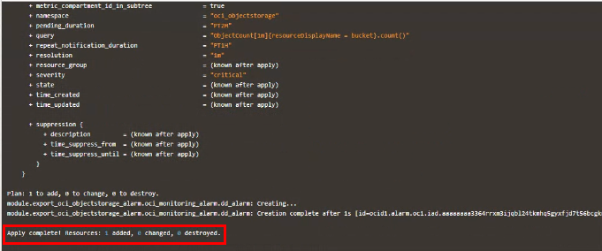

Verify in the Console
Go to OCI Console Monitoring Alarm definitions

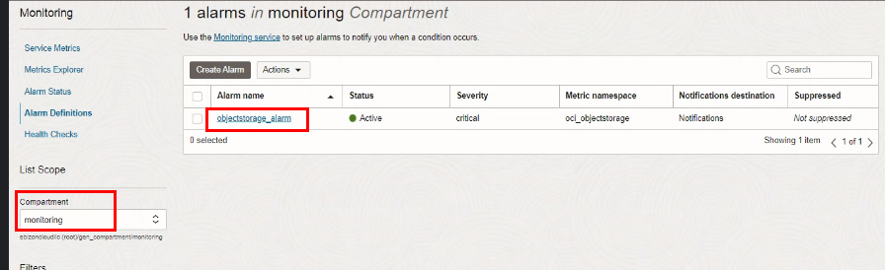

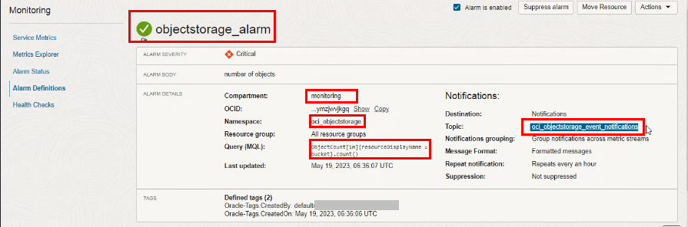

Destroy the stack

Create a destroy job in Resource Manager to release resources associated with a stack and clean up the tenancy. Once destroyed data cannot be recovered from resources.

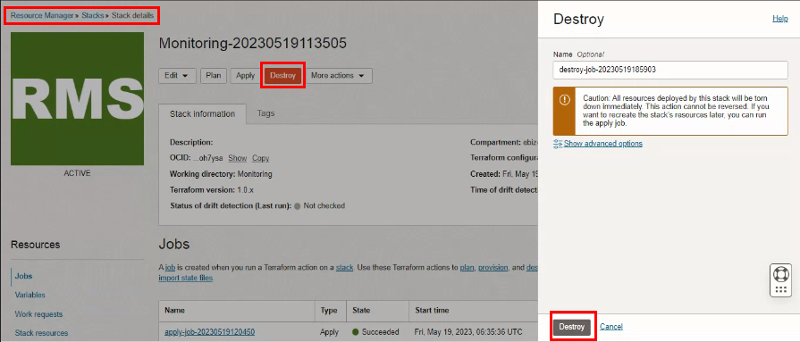

# END #

